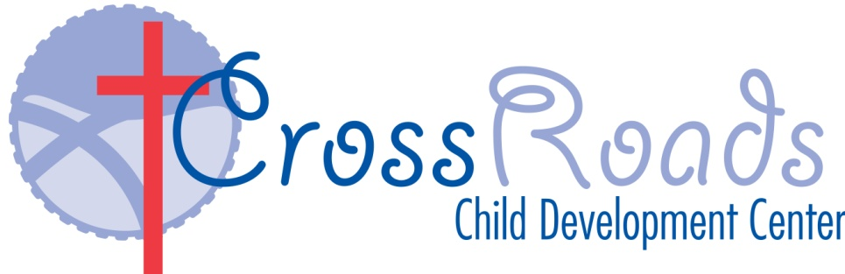

2024 - 2025 School Calendar
September March
2 Labor Day- CCDC CLOSED 17 St. Patrick’s Day
18 Progress Reports

October April 31 Halloween Celebration 17 Easter Celebration Closed at 3:00Pm 18 Good Friday CCDC Closed
21 Easter Monday CCDC Closed November May

8 Progress Reports
11 Professional Development Day CCDC Closed 26 Memorial Day CCDC CLOSED
12-15 Parent/Teacher Conferences
18-22 Parent/Teacher Conferences
27 Thanksgiving Celebration Closed at 3:00
28-29 Thanksgiving Break- CCDC CLOSED
December June

13 Christmas Pageant at 4 pm 12 CrossRoads Crossover/ Pre K Grad
20 Christmas Celebration 13 Teacher in service Day CCDC Closed 24-Jan 1 CCDC Closed Christmas/New Year Break 16 First Day of Summer Adventure
19 Juneteenth CCDC Closed

January July

20 MLK- CCDC CLOSED 3 4th of July celebration/ closed at 3:00 pm 4 July 4th Holiday- CCDC CLOSED

February August
14 Valentine’s Day Celebration 22 Last Day of Summer Adventure

